EV POWER AUSTRALIA – GOLDEN MOTOR
36V HUB MOTOR FITTING INSTRUCTIONS
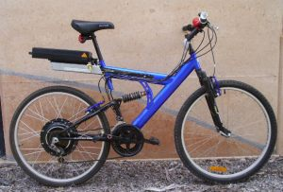

Before You Begin
Congratulations on the purchase of your Golden Motor 36V front or rear wheel hub motor kit. With correct fitting and careful use you should get years of pleasurable cycling from it. Please read these instructions prior to attempting installation.
Unpack the box and check the components:
1 x 26” Wheel complete with hub motor and 5 gear sprocket (rear kit only)
1 x 36V 500W Regen Braking controller
1 x twist grip throttle
2 x brake levers with electric regen connectors
1 x SLA battery level gauge
1 x 36V SLA Battery Charger
You will require the following extra components:
- Cable Ties to secure the cables to your bicycle
- Optionally an on/off toggle switch of the type sold in Automotive retailers
- 3 x SLA or AGM 12V batteries (6-12Ah recommended)
- A carrier or battery box to mount the batteries on the bicycle
The following tools will be required for installation:
- Adjustable wrench
- Pliers and/or side cutters
- Philips Screwdriver
- Flat screwdriver
- Hex key set.

Installing the wheel
The dropout on the front hub kit is 95mm which is standard for most front wheels. Steel forks can be widened slightly if required. Make sure the electric cable into the hub is on the left side of the bike.
Do not try to widen front suspension forks or aluminium/carbon fibre forks.

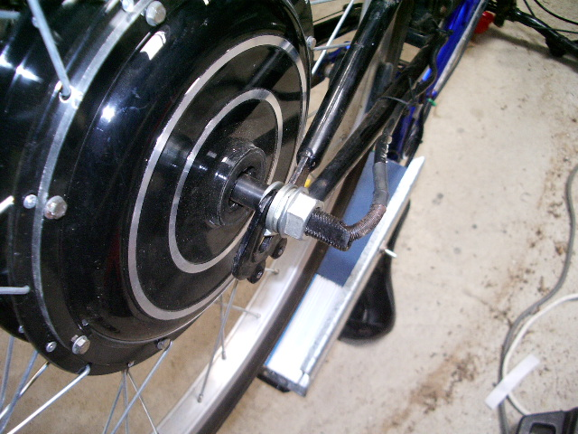
The dropout on the rear hub is 135mm which should fit most standard mountain bike frames. If your bike has a smaller dropout the frame may need to be widened slightly to accommodate the wheel. This can be done by using a piece of threaded rod with a nut on each end. Most rear forks will easily accommodate an extra 20 mm width gained in this way.

Please note that aluminium alloy and carbon fibre frames and forks cannot be altered in this way.
Don't try to alter the hub itself.
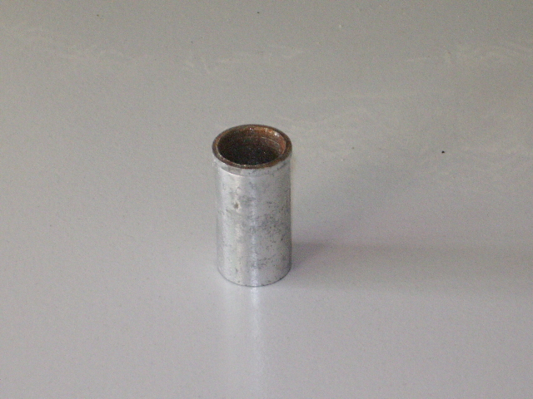
The rear wheel kits were supplied without an essential tubular spacer which belongs between the wheel nut and the hub inside the sprocket. This will have been delivered in the invoice window on the outside of the carton.
Please insert it before installing the wheel.

Adjusting the gears

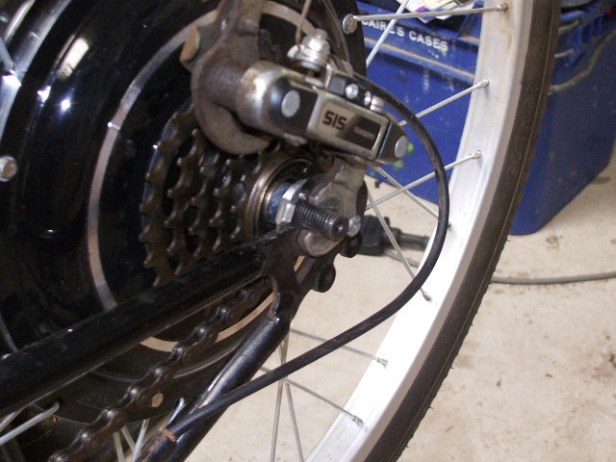
The rear wheel is supplied with a five gear sprocket. If your bike has seven or more gears than this it is a relatively simple matter to adjust the rear gears to suit. There are two screws on the rear dérailleur arm. These control the limits of the arms travel between the top and bottom gears. By adjusting these the correct range can be obtained..

Wiring

Consult the wiring diagram supplied. Most of the connectors will only fit one way. Make sure that the red wire goes to the battery positive. A switch may be required, these can be acquired at most auto shops.

The Phase detect jumper is unused. Make sure all wiring connections are away from moisture.

Warning: Please ensure that all wires are well connected. Controller failure can result when wires accidentally disconnect under load. In particular the three power wires leading to the motor should be firmly coupled so that they cannot be pulled apart by hand.

Install the twist throttle on the right handlebar and electric brakes on one or both handlebars. The electric brakes cut off power to the motor when the handbrakes are applied.

Battery Charger:

Warning: Do not plug the battery pack directly into mains electricity, even though it may appear to have a suitable plug. The same applies to the output plug of the battery charger.

The output may or may not have a plug supplied.
Take care to use the correct number of 12V batteries to make up the voltage of your charger.
Do not leave SLA batteries in a discharged state after riding, this will shorten their life.

Always charge the battery fully prior to the first use.

Riding Technique
The most useful feature of this type of bike is its ability to regenerate energy into the batteries when descending hills or slowing down. In general use the regen controller can be employed in such a way that the brakes will rarely be required to slow down the bike. There is a slight delay when twisting the grip and accelerating/decelerating, this is normal.

To increase the range of the batteries by using regen, the twist grip throttle should be reduced gradually as the speed reduces. A subtle vibration will be felt in the bike to indicate that the motor is working as a generator. When the throttle is released completely the bike will slow down but without recharging the battery.

If you do not wish to use the motor simply switch it off and the bike can be pedalled normally without resistance from regen.

Important Notes
Do not fully charge the batteries and then use regen braking down a hill. This may damage your batteries, controller or both.
When charging Lithium Iron Phosphate batteries do not leave them on long periods of float charge or you may shorten their life. Lithium batteries may be left partially discharged for periods of days or weeks if required.
Lithium Ion batteries can charge to a higher voltage than SLA batteries. Please ensure the controller is disconnected from the battery when charging or damage may result. It is best to wait a few minutes after charging before riding and start off carefully.
Every effort is made to ensure the highest quality of wheel kit for the price. However It should be noted that this technology is still very new and caution should be exercised when riding to prevent damage to the motor/controller or yourself. These kits are not made for rugged terrain.

